**CSCI 1100 – Summer 2015**

**Assignment 1 – Due Tuesday May 20th (11:00pm – night time)**

**Submit on Moodle**

**Name: Liam Gowan**

**Student ID:** B00673126

**Assignments are to be your own work. If you have questions, you can ask your Instructor, course TAs or TAs in the learning centre.**

|  |  |  |
| --- | --- | --- |
| **Declaration: Please complete this declaration** | | |
| 1 | “This document is entirely my own work.” | Yes/no |
| 2 | I obtained help to complete this document. | Yes/no. If Yes, give Details. |
| 3 | This document contains some material copied or cut and pasted from the internet or another document or file or program. | Yes/no. If Yes, give details and provide references. |

*Your task is to complete this report using Word and JGrasp and to submit the complete word document on Moodle. Acknowledge any help that you obtained from the Course or Learning Centre TAs in the table above.*

**Submit using Moodle. Make sure you double check that the file has been added to Moodle.**

**Question 1.** Write a java application that displays two triangles side by side. The program will ask for two numbers: one between 0-4 and one between 5-9. The first triangle will be filled in with the first number and the second (upside down) triangle will be filled in with the second number.

Printout of Properly Formatted Source Code

import java.util.Scanner; //Imports scanner class  
  
public class NumberTriangle  
{  
 public static void main(String[] args)  
 {  
 int num1, num2; //delcares integer variables  
 Scanner keyboard = new Scanner(System.in); //declares 'keyboard' as scanner type variable  
 System.out.print("Enter a number between 0-4: "); //Asks user to enter value   
 num1 = keyboard.nextInt(); //Assigns value to num1  
   
 /*If the value is less than 0, or greater than 4, the while loop  
 will ask for a number that is and will save that as num1 instead */  
   
 while(num1 < 0 || num1 > 4){  
 System.out.print("The number you entered was not between 0-4.\n" +   
 "Please try again: ");  
 num1 = keyboard.nextInt();  
 }  
   
 System.out.print("Enter a number between 5-9: "); //Asks user for a value  
 num2 = keyboard.nextInt(); //Assigns value to num2  
   
 /*If the value is less than 5, or greater than 9, the while loop  
 will ask for a number that is and will save that as num2 instead */  
   
 while(num2 < 5 || num2 > 9){  
 System.out.print("The number you entered was not between 5-9.\n" +   
 "Please try again: ");  
 num2 = keyboard.nextInt();  
 }  
   
 //This prints the triangle and upsidedown triangle with numbers.  
 System.out.println("\n " + num1 +" " + num2+ " " + num2+ " " + num2+ " " + num2+ "\n"  
 +" " + num1 + " " + num1 + " " + num2 + " " + num2 + " " + num2+ "\n"  
 +" " + num1 + " " + num1 + " " + num1 + " " + num2 + " " + num2 + "\n"  
 +" "+ num1 + " " + num1 + " " + num1 + " " + num1 + " " + num2);  
   
 }  
}

Example output/test cases (2 test cases).

Test 1.

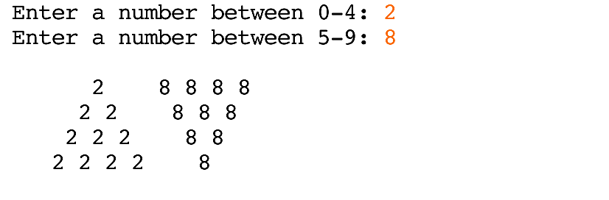

Test 2.

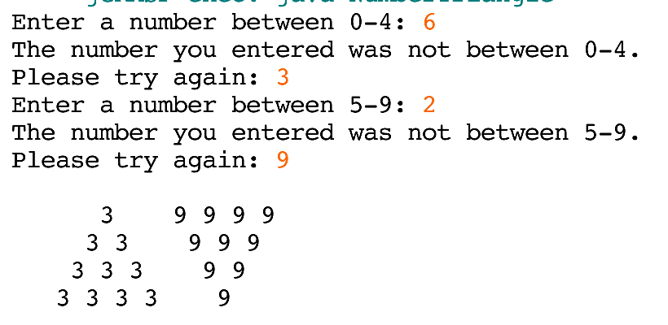

**Question 2.** Write a Java application that plays a word game with the user. The program asks the user to enter the following:

* Two names
* A sport
* An action (e.g, jumped, clapped)
* Two universities
* Your favorite food
* One number between 10 and 20

Printout of Properly Formatted Source Code

//This program shall request information from user for words, and make a story.  
  
import java.util.Scanner; //imports Scanner class  
  
public class MadLibs{  
 public static void main(String[] args){  
 String name1, name2, sport, action, uni1, uni2, food; int num; //Creates needed variables  
 Scanner input = new Scanner(System.in); //Creates variable "input" of scanner class  
   
 System.out.print("Enter your name: "); //Asks user for name  
 name1 = input.nextLine(); //Makes name1 equal to input  
 System.out.print("\nEnter another name: "); //Asks user for another name  
 name2 = input.nextLine(); //makes name2 equal to input  
 System.out.print("\nEnter a sport: "); //Asks user for a sport  
 sport = input.nextLine(); //Makes sport equal to input  
 //Below asks user for an action  
 System.out.print("\nThe last time you were happy, what action did you do: ");   
 action = input.nextLine(); //makes action equal to input  
 System.out.print("\nEnter the name of your university: "); //Asks user for name of univeristy  
 uni1 = input.nextLine(); //makes uni1 equal to input  
 System.out.print("\nEnter another university: "); //Asks user for another university  
 uni2 = input.nextLine(); //makes uni2 equal to input  
   
 /*While loop checks is the uni1 is equal to uni2 string.  
 If they are equal, it will ask user to put in another univeristy  
 and will then assign the string to uni2, ending the loop. */  
   
 while(uni1.equals(uni2)) {  
 System.out.print("You answered the same university twice."+   
 "\nPlease enter a different one: ");  
 uni2 = input.nextLine();  
 }  
   
 System.out.print("\nEnter your favourite food: "); //asks user for favourite food  
 food = input.nextLine(); //makes food equal to input  
 System.out.print("\nEnter a number between 10 and 20: "); //Asks user for a number  
 num = input.nextInt(); //makes num equal to input  
   
 /*This while loop checks to see if 'num' is less than 10, or  
 greater than 20. If it is, it will ask the user to put in  
 a number than is between 10 and 20. */  
   
 while(num < 10 || num > 20) {  
 System.out.println("Number invalid not between 10 and 20.");  
 System.out.print("Please enter a number between 10 and 20: ");  
 num = input.nextInt();  
 }  
 //The following prints out the story.  
 System.out.println("THIS IS THE BEST STORY EVER\n");  
 System.out.print("My name is " + name1 + ". ");  
 System.out.println("And my archenemy is " + name2+ ".");  
 System.out.println("I play " + sport + " for " + uni1 + " and "   
 + name2 + " plays for " + uni2 + ".");  
 System.out.println("At our last game we won by " + num + " points.");  
 System.out.println("I was so happy I " + action + " and I went out and"  
 + " ate my favourite food " + food + ".");  
 System.out.println("The End!");   
 }  
}

Example Output/Test Cases (2 outputs different from above)

Test 1.

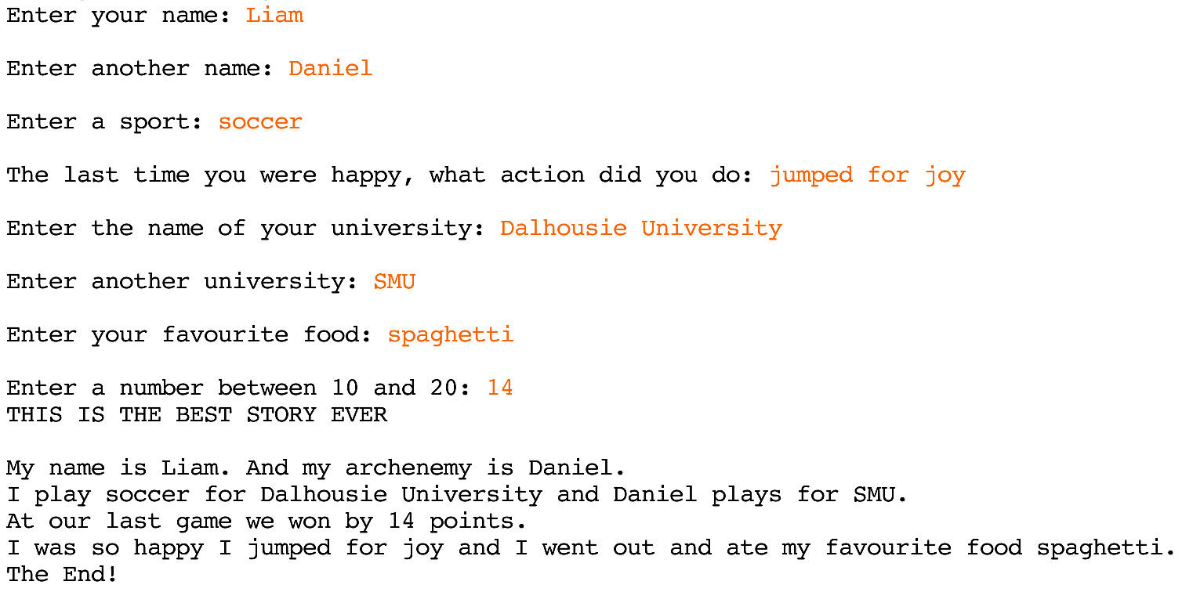

Test 2.

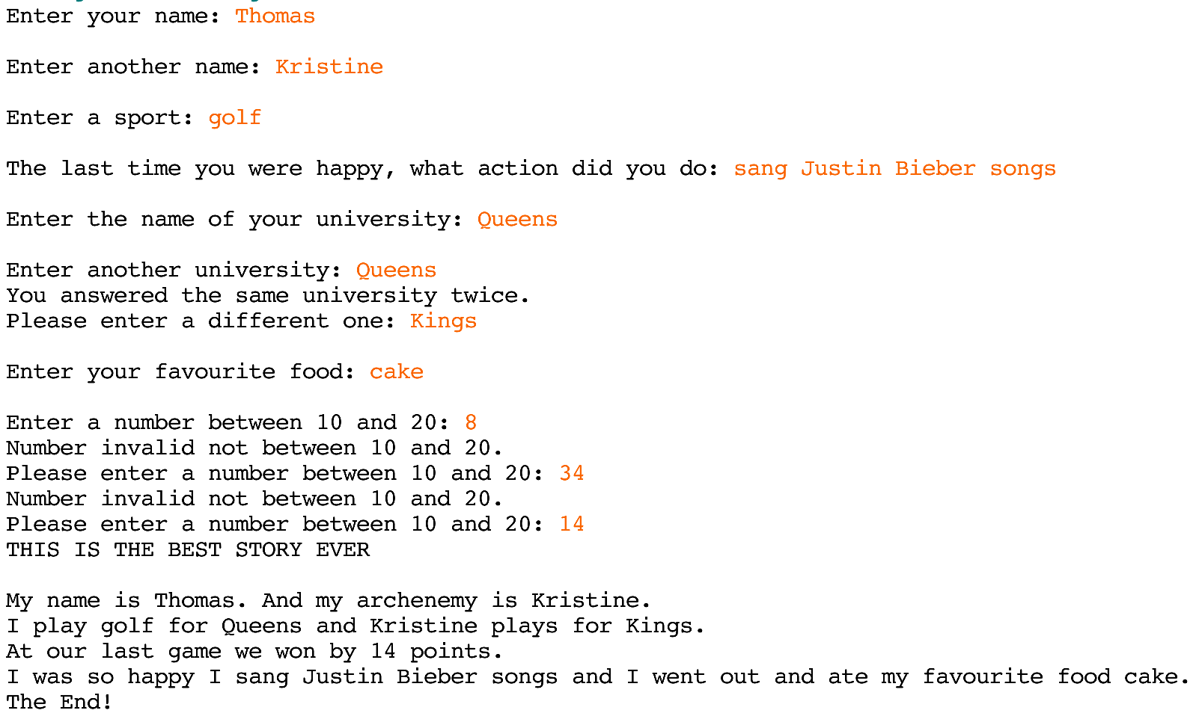

**Question 3.** Write a program that uses a Scanner object to read in user input.

Ask the user to enter a monetary value in cents (e.g., $12.50 dollars is 1250 in cents). Then display how many dollars, quarters, dimes, nickels and pennies make up that value.

Printout of Properly Formatted Source Code

import java.util.Scanner; //imports scanner class  
  
public class CashierHelper{  
 public static void main(String[] args) {  
 Scanner input = new Scanner(System.in); //creates scanner class variable, input  
 int total, dollars, quarters, dimes, nickles, pennies, remainder; //declares variables  
 //Declares string literals  
 String dollar_S = "dollars"; String quarter_S = "quarters";  
 String dime_S = "dimes"; String nickle_S = "nickles";  
 String penny_S= "pennies";  
   
 System.out.print("Enter an amount in cents: "); //Prompts user for monetary value  
 total = input.nextInt(); //assigns input to total  
   
 dollars = total/100; //Finds how many dollars are in total  
 remainder = total - (dollars*100); //Calculates remainder  
 quarters = remainder/25; //Finds how many quarter are in remainder  
 remainder = remainder - (quarters*25);//Calculates remainder  
 dimes = remainder/10; //Finds how many dimes are in remainder  
 remainder = remainder - (dimes*10); //Calculates remainder  
 nickles = remainder/5; //Finds how many nickles are in remainder  
 remainder = remainder - (nickles*5); //Calculates remainder  
 pennies = remainder; //Makes pennies the remaining amount  
   
 /*If there is only one coin (ex: one dollar), you would say "I have one  
 dollar", not "I have one dollars". The following if statements ensure  
 a proper string literal is used depending on if there is one or more coins.  
 */  
 if(dollars == 1){   
 dollar_S = " dollar, ";  
 }  
 if(dollars != 1){  
 dollar_S = " dollars, ";  
 }  
 if(quarters == 1){  
 quarter_S = " quarter, ";  
 }  
 if(quarters != 1){  
 quarter_S = " quarters, ";  
 }  
 if(dimes == 1){  
 dime_S = " dime, ";  
 }  
 if(dimes != 1){  
 dime_S = " dimes, ";  
 }  
 if(nickles == 1){  
 nickle_S = " nickle, ";  
 }  
 if(nickles != 1){  
 nickle_S = " nickles, ";  
 }  
 if(pennies == 1){  
 penny_S = " penny.";  
 }  
 if(pennies != 1){  
 penny_S = " pennies.";  
 }  
   
 //The following prints the total, and easiest way to make change.  
 System.out.print(total + " has " + dollars + dollar_S + quarters   
 + quarter_S + dimes + dime_S + nickles  
 + nickle_S + "and " + pennies + penny_S);  
 }  
}

Example Output/Test Cases (2 outputs different from above)

Test 1.



Test 2.



**Question 4.** Write a program that uses a Scanner object to read in user input.

Ask a user to enter three numbers. Then print the average of the three numbers, the smallest of the three numbers and the largest of the three numbers. See the below sample for proper formatting of the output. Do not concern yourself with controlling the display of the decimal point.

Printout of Properly Formatted Source Code

import java.util.Scanner; //imports scanner class  
  
public class NumberCalc{  
 public static void main(String[] args){  
 double num1, num2, num3, average, maximum, minimum; //declares double variables  
 Scanner input = new Scanner(System.in); //makes input a scanner variable  
   
 System.out.print("Please enter number 1: "); //asks user for 1st number  
 num1 = input.nextDouble(); //Assigns input to num1  
 System.out.print("Please enter number 2: "); //asks user for 2nd number  
 num2 = input.nextDouble(); //Assigns input to num2  
 System.out.print("Please enter number 3: "); //asks user for 3rd number  
 num3 = input.nextDouble(); //Assigns input to num3  
   
 average = (num1 + num2 + num3)/3.0; //Calculates average  
   
 /*Since Math.max can only accept two arguments, the maximum value of   
 num1 and num2 is saved to maximum. Then a second Math.max is performed,  
 finding the maximum between the first maximum and num3. */  
   
 maximum = Math.max(num1, num2);  
 maximum = Math.max(maximum, num3);  
   
 /*Since Math.min can only accept two arguments, the minimum value of   
 num1 and num2 is saved to minimum. Then a second Math.min is performed,  
 finding the minimum between the first minimum and num3. */  
   
 minimum = Math.min(num1, num2);  
 minimum = Math.min(minimum, num3);  
   
 //The following prints the numbers, average, min and max value.  
 System.out.print("The average of " + num1 + ", " + num2 + ", "  
 + num3 + " is " + average + ".\n" +  
 "The largest number is " + maximum + ".\n" +  
 "The smallest number is " + minimum + ".");  
 }  
}

Example Output/Test Cases (2 outputs different from above)

Test 1.

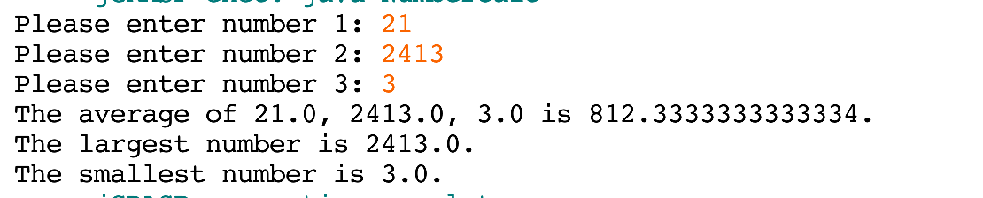

Test 2.

